training 1 epoch...

240.7976372241974 seconds used......

1 training finished! average train loss: 0.8643150794122255

evaluating...

Confusion matrix, without normalization

[[ 1 6 114]

[ 2 39 66]

[ 0 19 339]]

Normalized confusion matrix

[[0.00826446 0.04958678 0.94214876]

[0.01869159 0.36448598 0.61682243]

[0. 0.05307263 0.94692737]]

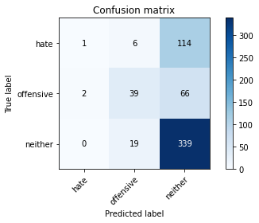

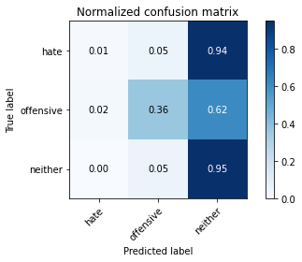

precision recall f1-score support

hate 0.33 0.01 0.02 121

offensive 0.61 0.36 0.46 107

neither 0.65 0.95 0.77 358

accuracy 0.65 586

macro avg 0.53 0.44 0.42 586

weighted avg 0.58 0.65 0.56 586

average eval_loss: 0.7895365496476491, accuracy: 0.6467576791808873

training 2 epoch...

248.81884217262268 seconds used......

2 training finished! average train loss: 0.7398155001979886

evaluating...

Confusion matrix, without normalization

[[ 5 12 104]

[ 3 48 56]

[ 3 34 321]]

Normalized confusion matrix

[[0.04132231 0.09917355 0.85950413]

[0.02803738 0.44859813 0.52336449]

[0.00837989 0.09497207 0.89664804]]

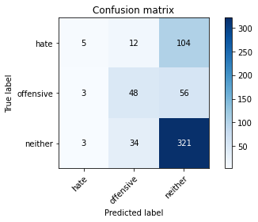

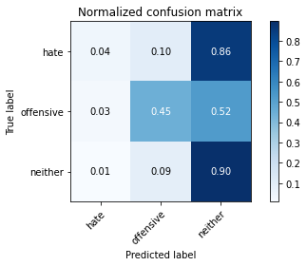

precision recall f1-score support

hate 0.45 0.04 0.08 121

offensive 0.51 0.45 0.48 107

neither 0.67 0.90 0.77 358

accuracy 0.64 586

macro avg 0.54 0.46 0.44 586

weighted avg 0.59 0.64 0.57 586

average eval_loss: 0.7839934607346852, accuracy: 0.6382252559726962

training 3 epoch...

249.0288655757904 seconds used......

3 training finished! average train loss: 0.6013363130164869

evaluating...

Confusion matrix, without normalization

[[ 13 7 101]

[ 7 45 55]

[ 13 26 319]]

Normalized confusion matrix

[[0.10743802 0.05785124 0.83471074]

[0.06542056 0.42056075 0.51401869]

[0.03631285 0.0726257 0.89106145]]

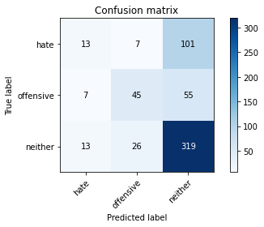

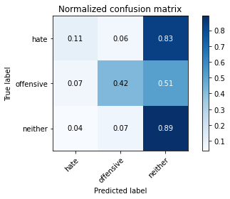

precision recall f1-score support

hate 0.39 0.11 0.17 121

offensive 0.58 0.42 0.49 107

neither 0.67 0.89 0.77 358

accuracy 0.64 586

macro avg 0.55 0.47 0.47 586

weighted avg 0.60 0.64 0.59 586

average eval_loss: 0.9062104632457098, accuracy: 0.643344709897611

training 4 epoch...

249.0342800617218 seconds used......

4 training finished! average train loss: 0.38734287119498756

evaluating...

Confusion matrix, without normalization

[[ 15 10 96]

[ 11 37 59]

[ 31 19 308]]

Normalized confusion matrix

[[0.12396694 0.08264463 0.79338843]

[0.10280374 0.34579439 0.55140187]

[0.08659218 0.05307263 0.8603352 ]]

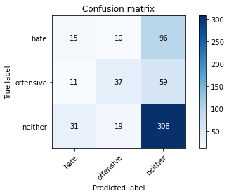

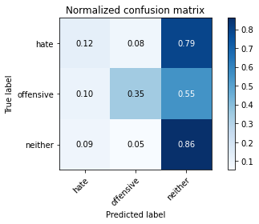

precision recall f1-score support

hate 0.26 0.12 0.17 121

offensive 0.56 0.35 0.43 107

neither 0.67 0.86 0.75 358

accuracy 0.61 586

macro avg 0.50 0.44 0.45 586

weighted avg 0.56 0.61 0.57 586

average eval_loss: 1.1563205882906913, accuracy: 0.6143344709897611

training 5 epoch...

248.44745230674744 seconds used......

5 training finished! average train loss: 0.1760270270434293

evaluating...

Confusion matrix, without normalization

[[ 58 13 50]

[ 24 59 24]

[104 40 214]]

Normalized confusion matrix

[[0.47933884 0.10743802 0.41322314]

[0.22429907 0.55140187 0.22429907]

[0.29050279 0.11173184 0.59776536]]

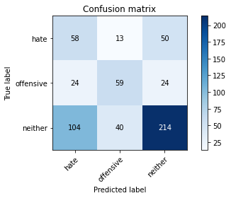

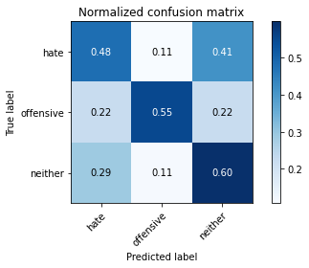

precision recall f1-score support

hate 0.31 0.48 0.38 121

offensive 0.53 0.55 0.54 107

neither 0.74 0.60 0.66 358

accuracy 0.56 586

macro avg 0.53 0.54 0.53 586

weighted avg 0.61 0.56 0.58 586

average eval_loss: 1.5102610071500142, accuracy: 0.5648464163822525

model of 5 epoch

Confusion matrix, without normalization

[[ 82 17 25]

[ 36 107 21]

[271 41 553]]

Normalized confusion matrix

[[0.66129032 0.13709677 0.2016129 ]

[0.2195122 0.65243902 0.12804878]

[0.3132948 0.04739884 0.63930636]]

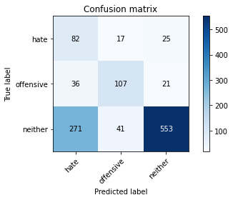

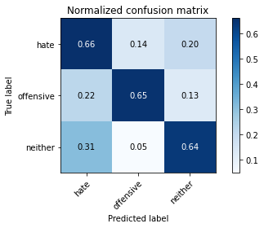

precision recall f1-score support

hate 0.21 0.66 0.32 124

offensive 0.65 0.65 0.65 164

neither 0.92 0.64 0.76 865

accuracy 0.64 1153

macro avg 0.59 0.65 0.58 1153

weighted avg 0.81 0.64 0.69 1153

average eval_loss: 1.2523551146531928, accuracy: 0.6435385949696444

0.6435385949696444